\* The same steps for Switch &Router

الطريقة الأولى لتغيير الـ

*Router-Host name :*

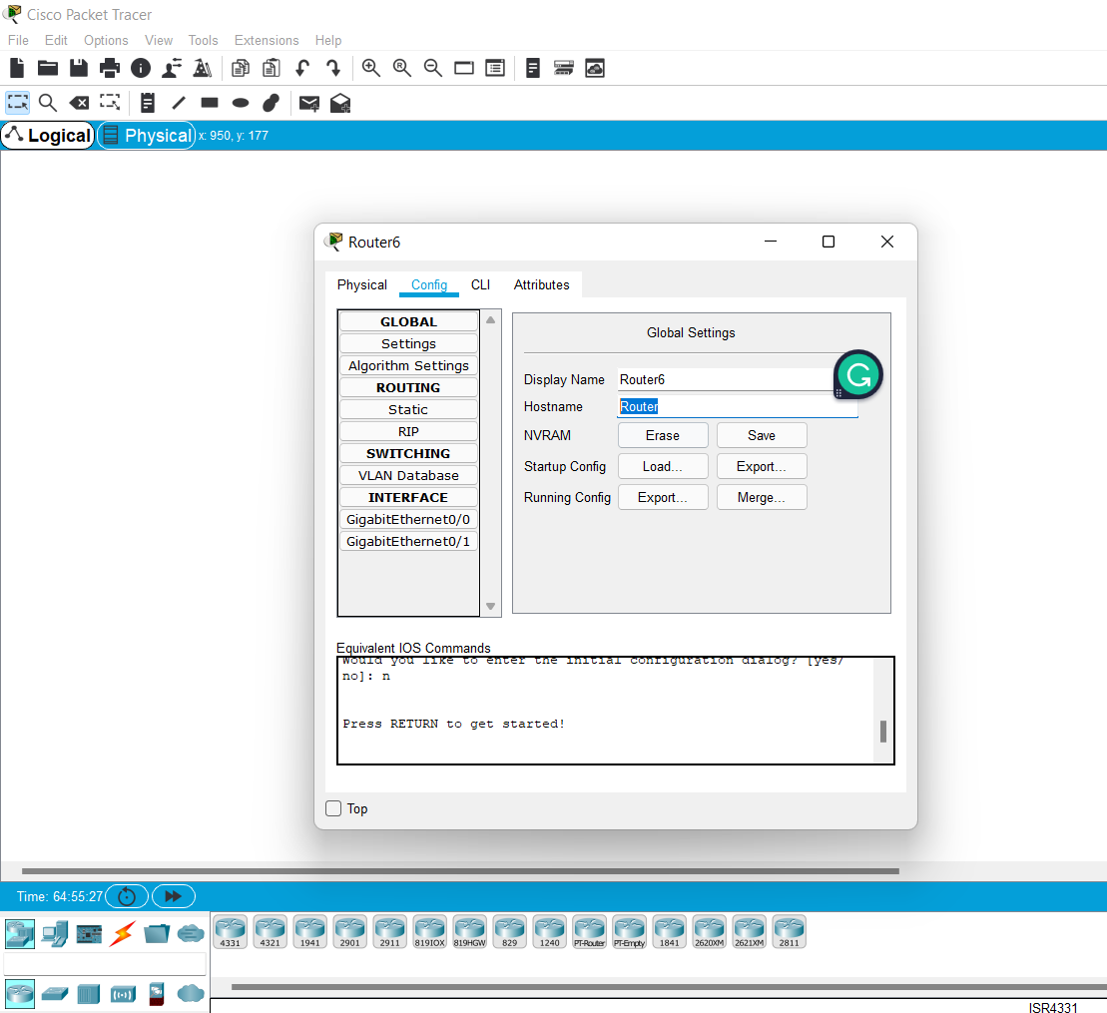

*Config Hostname*

\*الطريقة الثانية لتغيير الـ

*Router-Hostname:*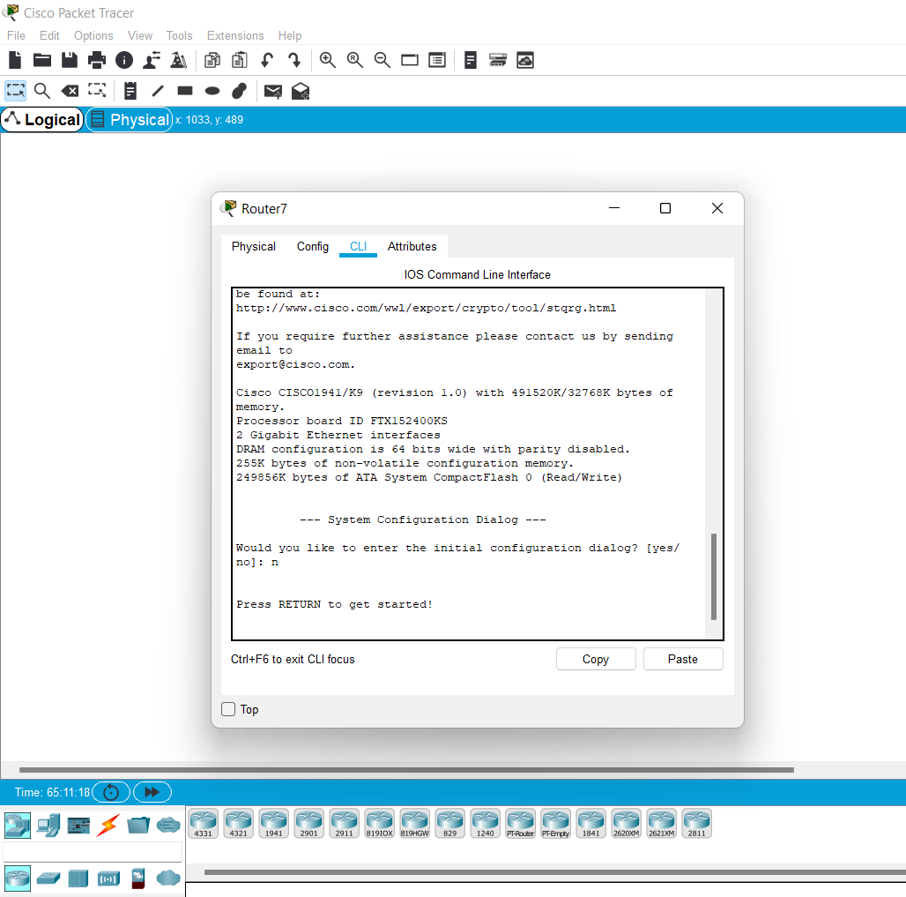

*CLI after get started press enter*

*Router > write enable*

*Router # write config example*

*Router (config ) # write hostname R1*

*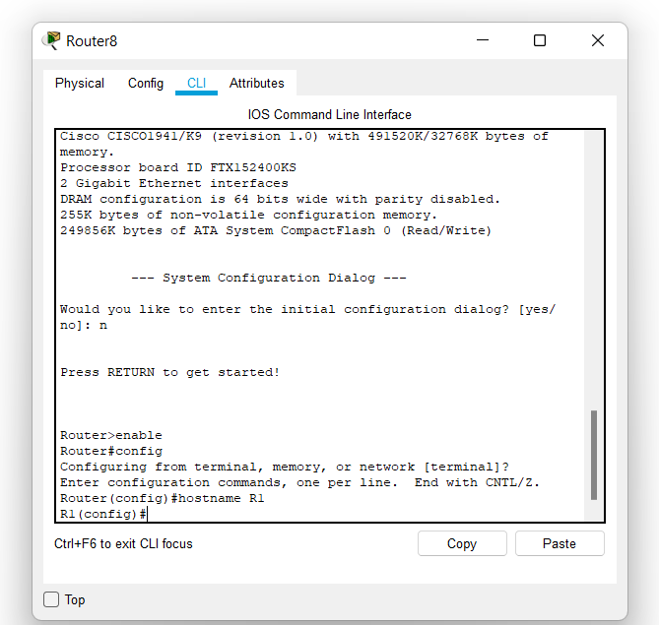*

*Hostname Done*

**

*How to create a password:*

*ــInside (R1 (config)#) write line console 0 example*

*R1( config-line) # write password cisco123*

*R1 (config-line) # write login*

*R1 (config-line)# write exit*

*R1(config)# write exit*

*R1#*

*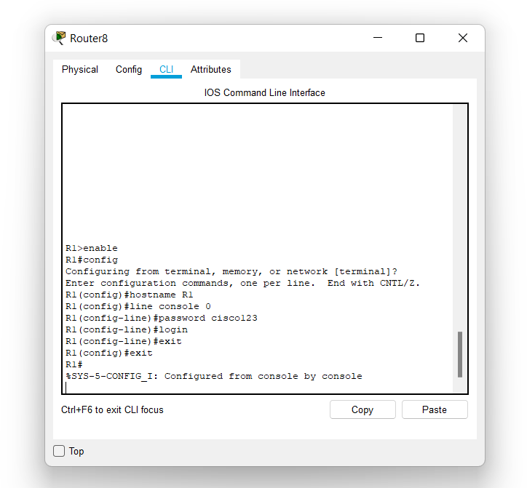*

*ــ To show the information :*

*Inside R# write show run*

*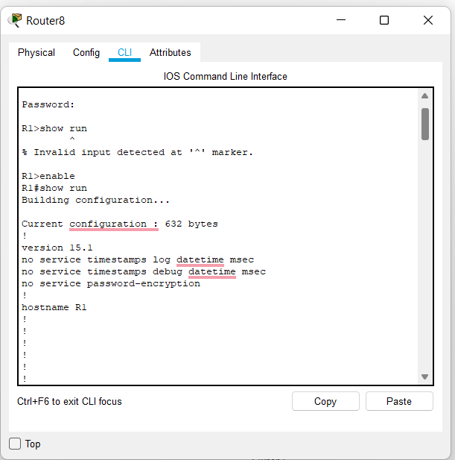*

*ــ To create a password for configuration :*

*Inside R1# write config example*

*R1 (config)# write enable password 1234cisco*

*R1 # write exit*

*ــ* To store information from temporary settings to permanent settings:

Inside R1 write copy run startup-config

Press Enter

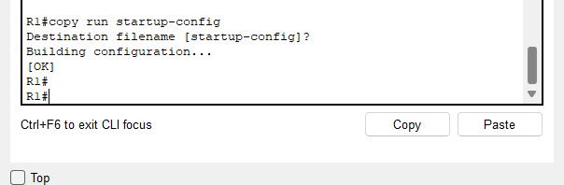

*ــ To encode password :*

*Inside R1 write config t*

*R1 (config ) write service password-encryption*

*R1 (config) write exit*

*R1 # write show running*

*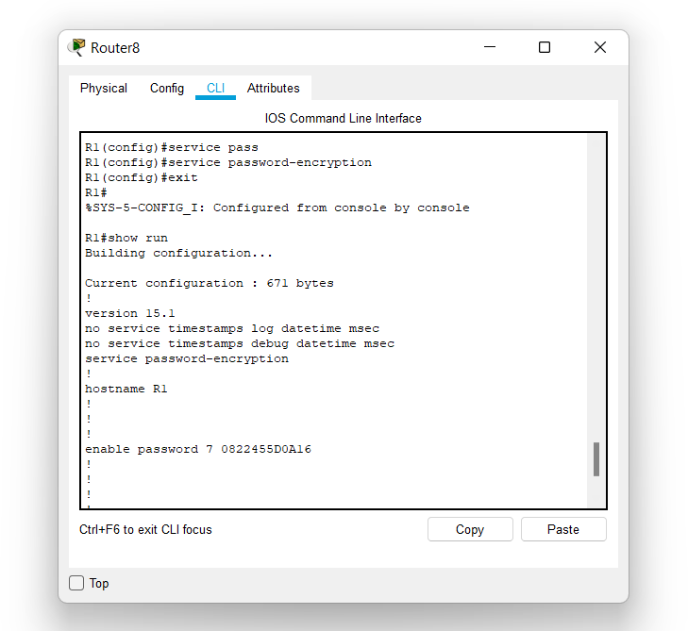*

*ــ To create message (message of the day (motd)) : example*

*Inside R1(config)# write banner motd “Hello world “*

*“ ” important*

*R1 (config ) # write exit*

*R1 # write show run*

*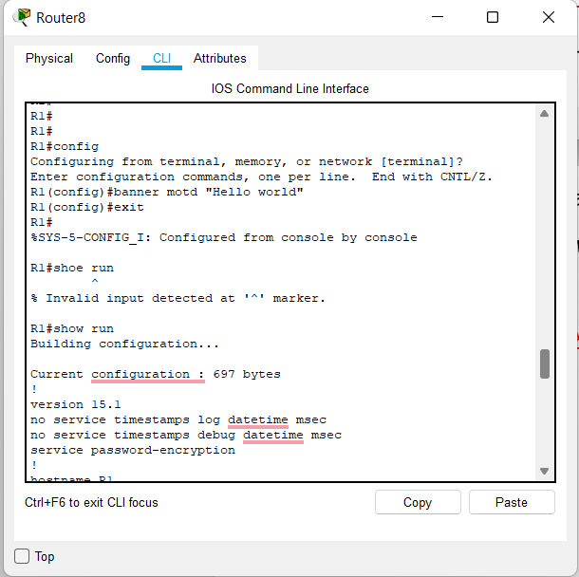*

*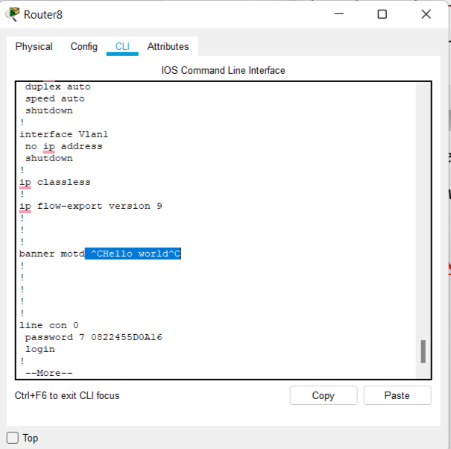*

*Good luck \*-\**